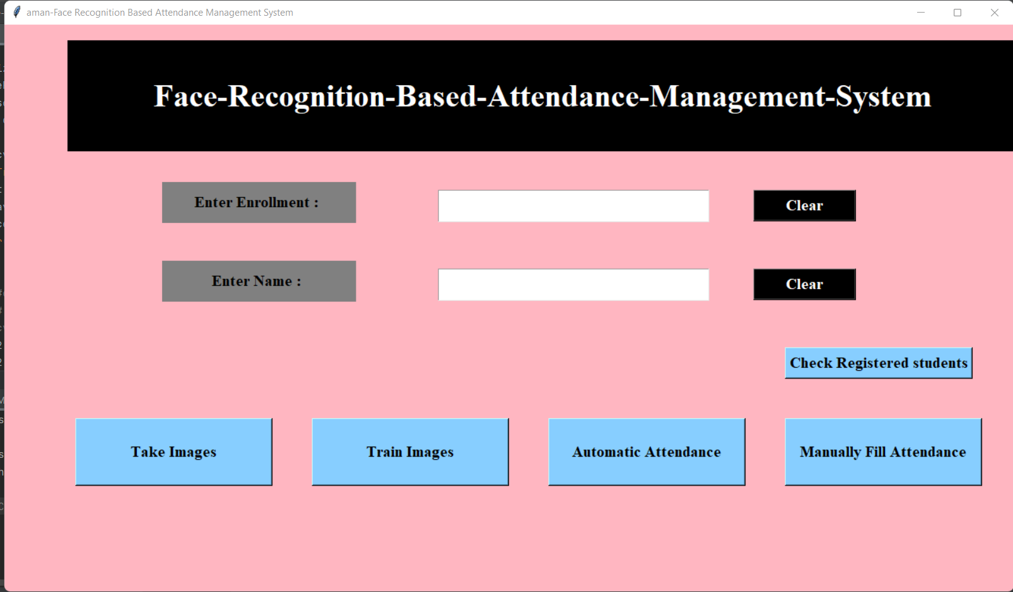

First page

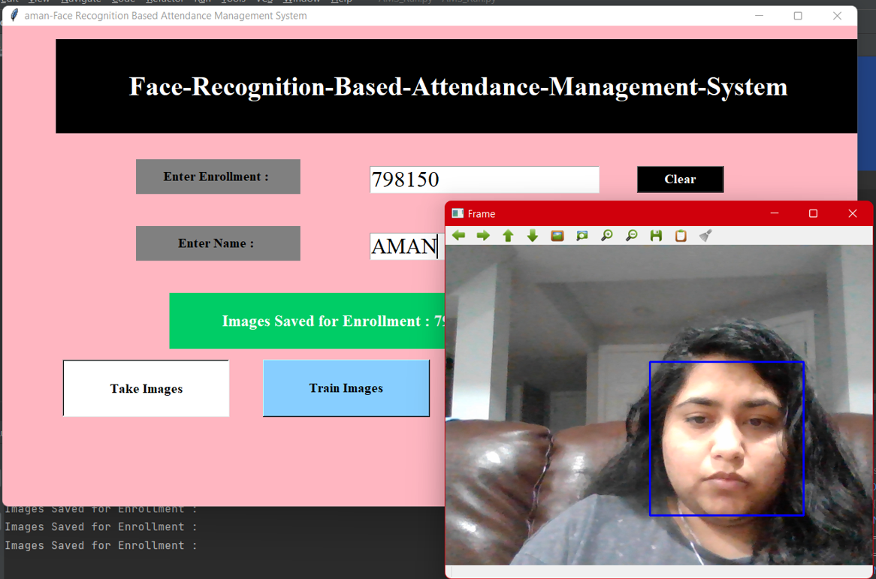

Video capturing part

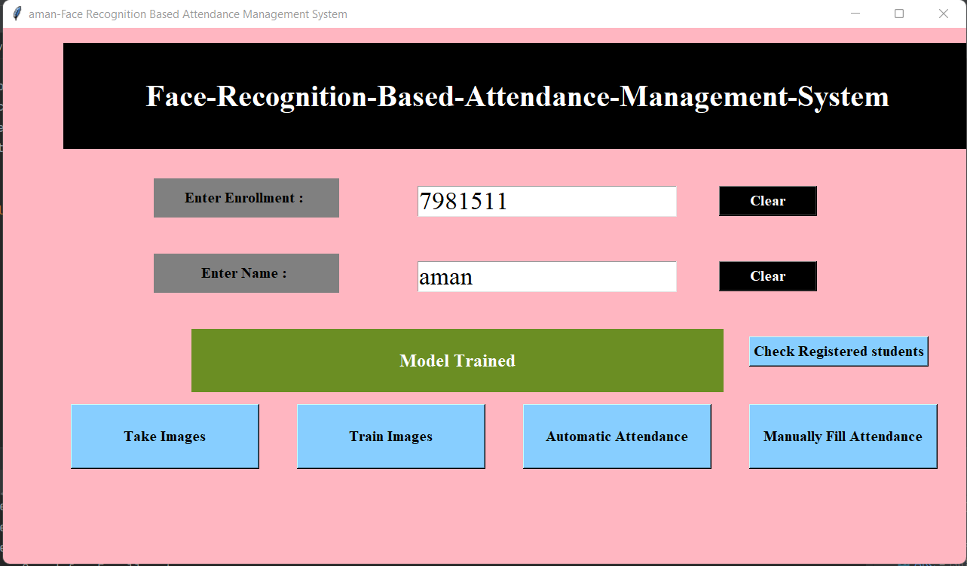

Training model

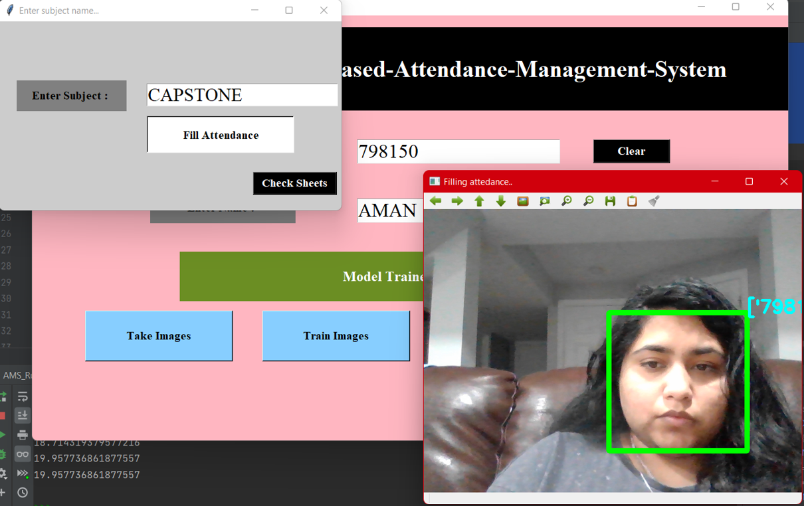

Automatic fill attendance

Attendance filled and shows as grid for registered students

The final part is the testing part in this it shows the id and name of the registered student.